EXPERIMENT-17
Title: To understand the concepts of Trigger.
Objective: Students will be able to implement the concept of trigger.
1. CREATE TRIGGER SALARY_VIOLATION BEFORE INSERT OR UPDATE OF SALARY,
SUPERVISOR_SSN ON EMPLOYEE of experiment 3
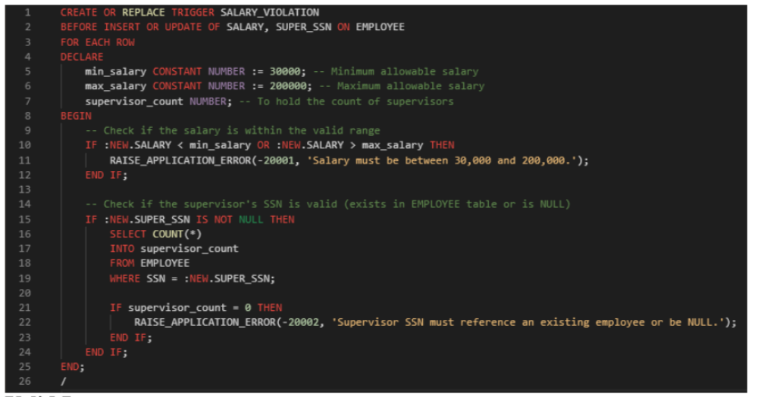
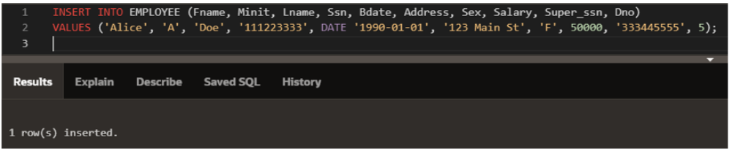
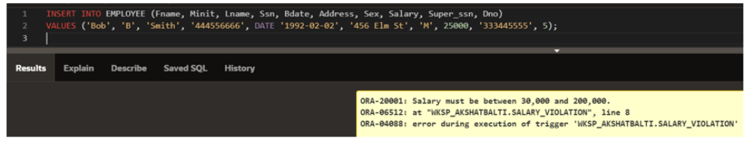
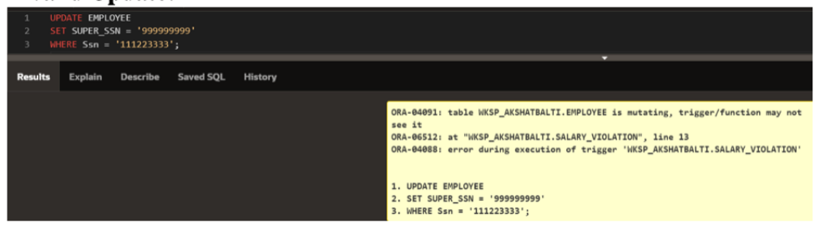
EXPERIMENT-18
Title: To understand the concepts of NoSQL Database
Objective: Students will be able to implement the concept of NoSQL Database MongoDB.
1. Write a MongoDB query to display all the documents in the collection hotel.
2. Write a MongoDB query to display the fields hotel_id, name, Borough and cuisine for all the
documents in the collection hotel.
3. Write a MongoDB query to display the fields hotel_id, name, Borough and cuisine, but exclude
the field _id for all the documents in the collection hotel.
4. Write a MongoDB query to display the fields hotel_id, name, Borough and zip code, but
exclude the field _id for all the documents in the collection hotel. hotel
5. Write a MongoDB query to display all the hotel which is in the Borough Bronx.
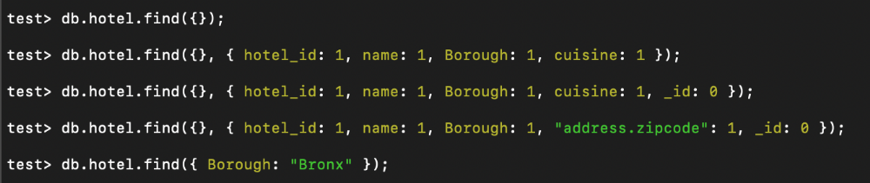
EXPERIMENT-19
Title: To understand the concepts of NoSQL Database
Objective: Students will be able to implement the concept of NoSQL Database MongoDB.
1. Write a MongoDB query to display the next 5 hotels after skipping first 5 which are in the
Borough Bronx.
2. Write a MongoDB query to find the hotels that achieved a score, more than 80 but less than
100.
3. Write a MongoDB query to find the hotels which locate in latitude value less than -95.75
4. Write a MongoDB query to find the hotels that do not prepare any cuisine of 'American' and
their grade score more than 70 and latitude less than -65.754168.
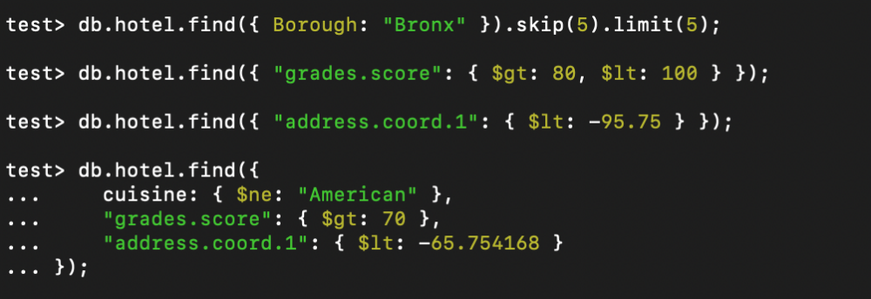
EXPERIMENT-20
Title: To understand the concepts of NoSQL Database
Objective: Students will be able to implement the concept of NoSQL Database MongoDB.
1. Write a MongoDB query to arrange the name of the cuisine in ascending order and for that
same cuisine Borough should be in descending order.
2. Write a MongoDB query to know whether all the addresses contains the street or not.
3. Write a MongoDB query which will select all documents in the hotels collection where the coord
field value is Double.
4. Write a MongoDB query which will select the hotel Id, name and grades for those hotels which
returns 0 as a remainder after dividing the score by 7.
5. Write a MongoDB query to find the hotel name, Borough, longitude and attitude and cuisine for
those hotels which contains 'mon' as three letters somewhere in its name.
6. Write a MongoDB query to find the hotel name, Borough, longitude and latitude and cuisine for
those hotels which contain 'Mad' as first three letters of its name.
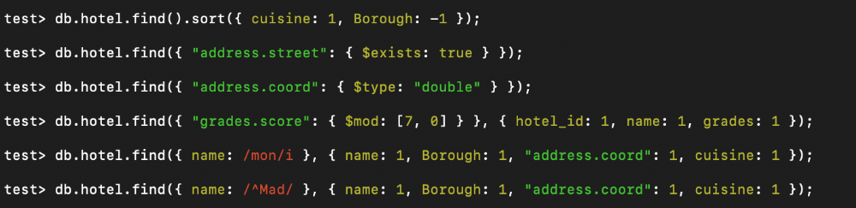
EXPERIMENT-21
Title: To understand the concepts of NoSQL Database
Objective: Students will be able to implement the concept of NoSQL Database MongoDB.
1. Write a MongoDB query to find the hotels which do not prepare any cuisine of
'American' and achieved a score more than 70 and located in the longitude less than
-65.754168.
2. Write a MongoDB query to find the hotels which do not prepare any cuisine of 'American
' and achieved a grade point 'A' not belongs to the Borough Brooklyn. The document must
be displayed according to the cuisine in descending order.
3. Write a MongoDB query to find the hotel Id, name, Borough and cuisine for those hotels
which contain 'ces' as last three letters for its name.
4. Write a MongoDB query to find the hotel Id, name, Borough and cuisine for those hotels
which contain 'Reg' as three letters somewhere in its name.
5. Write a MongoDB query to find the hotels which belong to the Borough Bronx and
prepared either American or Chinese dish.
6. Write a MongoDB query to find the hotel Id, name, Borough and cuisine for those hotels
which belong to the Borough Staten Island or Queens or Hyatt.
7. Write a MongoDB query to find the hotel Id, name, Borough and cuisine for those hotels
which are not belonging to the Borough New Delhi or Queens or Hyatt.
8. Write a MongoDB query to find the hotel Id, name, Borough and cuisine for those hotels
which achieved a score which is not more than 10.
9. Write a MongoDB query to find the hotel Id, name, Borough and cuisine for those hotels
which prepared dish except 'American' and 'Chinees' or hotel's name begins with letter
'Wil'.
10. Write a MongoDB query to find the hotel Id, name, and grades for those hotels which
achieved a grade of "A" and scored 11 on an ISODate "2014-08-11T00:00:00Z" among
many of survey dates.
